 CHEMICAL ENGINEERING TRANSACTIONS  VOL. xxx, 2025 | A publication of  
The Italian Association
of Chemical Engineering
Online at www.cetjournal.it
Guest Editors: David Bogle, Flavio Manenti, Piero Salatino
Copyright © 2025, AIDIC Servizi S.r.l.
ISBN 979-12-81206-21-2; ISSN 2283-9216
A Process Engineering Analysis on the Impact of Electrification on India’s Petrochemical Sector
Bhawna Chauhan^{a*}, Asad H. Sahir^{b}
ªIndian Institute of Technology Ropar, Rupnagar (Punjab) -140001
^{b}Indian Institute of Technology Ropar, Rupnagar (Punjab) -140001
​
The petrochemical sector of India is growing rapidly, with an expected investment of ~USD 87 billion in the next 10 years. This paper showcases the development of a Linear Programming (LP) framework integrated with energy system modelling towards analysing optimal feedstock utilization, production planning, and carbon emissions reduction under varying market scenarios. By utilizing available Government of India data and literature studies on optimization, a data-driven approach is proposed that provides a framework to encourage planning for cost efficiency, reducing dependence on imported feedstocks, and subsequently helps strengthen India's position in global petrochemical markets.
Another idea investigated is the potential of renewable energy integration using the ONSET tool for assessing the impact on decarbonizing ethylene production, an important petrochemical. Considering an optimistic growth rate (10%) scenario, this study estimates total ethylene production of 10.63 million tonnes and the calculated energy required for steam cracking of ethylene as 276 PJ. These evaluations are used to assess carbon emissions from both conventional and renewable-powered steam crackers. The results of this analysis are expected to be of interest to technology developers, the process engineering community, and policymakers who are working towards reducing carbon footprints and enhancing sustainability to achieve India’s net-zero goal by 2070.
  - Introduction
The petrochemical industry plays an important role in various sectors, including manufacturing, agriculture, healthcare, and construction. It provides necessary raw materials for producing plastics, synthetic fibres, fertilizers, pharmaceuticals, and various other products. India is one of the largest consumers of petrochemicals in Asia, with upcoming projects focusing on meeting future requirements. In 2022, global chemical sales (excluding pharmaceuticals) reached approximately $220 billion, IBEF (2025). India ranks 6th globally and 4th in Asia in terms of chemical sales FICCI (2022). The Indian chemical industry was valued at $220 billion in 2022, with projections indicating it to grow to $300 billion by 2025. Additionally, the demand for petrochemicals in India is expected to triple by 2040, leading to planning for capacity expansions.
In India, Petrochemical production depends on various feedstocks, including ethane, propane, butane, Liquified Petroleum Gas (LPG), natural gas, and naphtha. The choice of feedstock is influenced by factors such as availability, cost, and processing efficiency. Asia, mainly India and China, accounts for 60% of the world's naphtha consumption, making it the largest player in the global petrochemical sector IEA (2022). The use of natural gas in India is projected to grow at a compound annual growth rate (CAGR) of 12.2%, reaching 550 million m³ per day by 2030 PPAC (2023). The increasing volatility in feedstock prices and availability emphasizes the need for strategic optimization models to manage resources effectively.
Linear Programming models for the petrochemical industry, which provide valuable insights into production planning, cost minimization, and supply chain optimization have been explored in several studies. Early research by Manne and Markowitz (1961) analysed production capabilities; however, their work did not account for demand fluctuations or economic constraints. Stadtherr and Rudd (1978) investigated the impact of changes in feedstock supply on industry structure, providing a foundation for long-term strategic planning. Based on these two seminal contributions Fathi-Afshar et al. (1981) introduced economic considerations such as capital investment, operating costs, and product pricing into Linear Programming frameworks, enhancing their applicability to real-world industrial scenarios. Further advancements include Fathi-Afshar and Yang (1985), who developed a model balancing production costs and environmental impact, addressing sustainability concerns. Recently, Derosa et al. (2019) created a comprehensive chemical industry network model for the United States, which analysed disruptions caused by external factors such as hurricanes, demonstrating the resilience of different supply chain configurations.
In India, existing research has primarily focused on industry structure, technology transfer, and capacity expansion (Kapur, 1994). However, there is a gap in the application of optimization models to improve efficiency and support strategic planning which the current study seeks to bridge.
  - Development of an optimization model for feasible feedstock evaluation
Linear Programming (LP) is recognized as an important tool in process systems engineering for optimizing production, resource allocation, and cost efficiency within complex industrial systems. In the context of petrochemical operations, LP enables the mapping of feedstock availability to final product outputs under multiple constraints such as process capacities, demand requirements, and cost structures.
Previously, several studies have been done to develop mathematical models of the petrochemical industry to understand the petrochemical industry scenario. In their study, Manne analysed the potential product mix of alternatives that can be considered using the refining equipment and raw materials available in the United States Manne and Markowitz (1961). They developed a Linear Programming (LP) model for the analysis of production capabilities in the petrochemical industry and industrial complexes, in which they considered only capacity constraints. Subsequently, Stadtherr & Rudd (1978) studied shadow prices, which represent how much the objective value (such as total profit or cost) would change if the availability of a constrained resource (i.e., the right-hand side of a constraint) increased by one unit, assuming all other parameters remain constant. and compared them with theoretical feedstock requirements, they also analysed the effect of perturbations such as feedstock supply in the industry. The insights from the literature have been utilized to develop the Linear Programming model for the Indian Petrochemical industry in this study.
This study follows a stepwise approach to analyse the impact of electrification on India’s petrochemical sector. Data collection was carried out using reliable and official sources, including the Petroleum Planning and Analysis Cell (PPAC) for natural gas prices, the Federation of Indian Chambers of Commerce and Industry (FICCI) and the International Energy Agency (IEA) for demand projections, and the ONSET tool for energy and emissions-related data.
The ONSET (Options for National-scale Energy Transition) model is a systems-based decision-support framework designed to evaluate national energy transition strategies. It enables analysis of various technology options, estimates associated greenhouse gas emissions and assesses energy supply-demand balances under different policy or market scenarios. This helps policymakers and researchers identify optimal pathways for achieving low-carbon, sustainable development. Additional data were obtained from peer-reviewed literature
  - Model Assumptions:
The LP model is based on the following assumptions:
- The chemical industry can be visualized and represented as a network of chemical processes.
- Material flows define the processes that involve chemical and/or physical transformations. The material interactions among processes are linear, and thus the processing network is represented as a linear input/output matrix
- There exists a specific supply/demand environment and process capacity limitations.
- Transportation and environmental externalities are excluded.
  - Objective Function:
The economic model of the industry is shown in Figure.1. includes processes that transform chemical intermediates and feedstocks, and within the specified process capacity limits B_{j}​. The feedstock supply constraints at the national level are represented by S_{i}​. The objective function aims to optimize production levels X_{j}​ such that total production costs, represented by C_{j}X_{j}​, are minimized, keeping the revenue from exports, given by E_{i​}Q_{i}​. This approach ensures that market demand is met effectively while keeping overall production expenses as low as possible as per Eq 1 Al-Amer et al. (1998).
$Profit=\sum_{i=1}^{n}{E_{i}Q_{i} }- \sum_{i=1}^{n}{C_{j}X_{j} }$ (1)
  - Constraints: The constraints considered in the model are as follows:
2.3.1. Supply Limitations: The availability of raw materials and feedstocks is expected to be limited by factors such as seasonal variations, market conditions, or geopolitical issues. Skouteris et al. (2021).
i) Process Capacity Limitations: This limitation ensures that production does not exceed the maximum capacity of the equipment. it also ensures that the production rate prevents operational inefficiencies or breakdowns
ii) Demand constraints: These are related to market demand, including seasonal variations, customer preferences, and contractual obligations. Figure 1 shows the components of the model
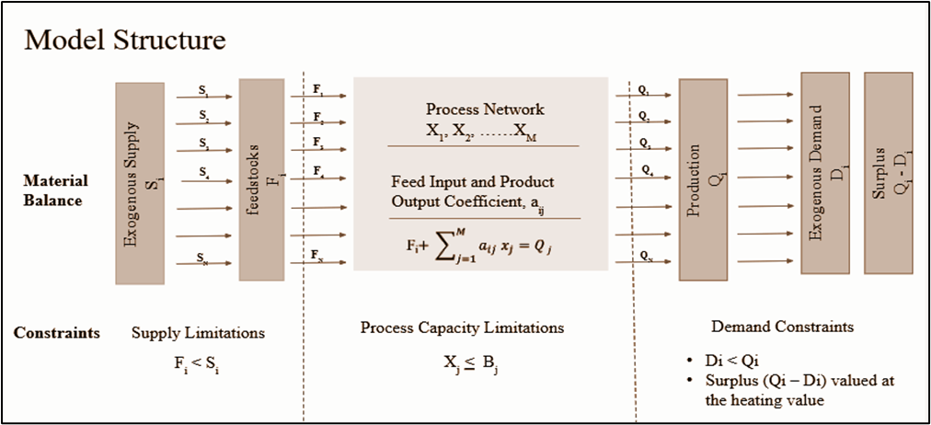
Figure 1: Linear Programming Model Structure for the Indian Petrochemical Industry, Al-Amer et al. (1998).
2.3.2. Lower Bound: Minimum Production Levels: Some petrochemical production processes have minimum operating levels due to technical or economic reasons.
2.3.3. Upper Bound: Three variables can be specified as the Upper Bound:
i)Process Capacity (B_{j}): The process capacity represents the maximum production level for each process. ii)Feedstock Supply (S_{i}) represents the maximum number of raw materials available for processes.
iii) Product Demand (D_{i}): Product demand may be considered as a target that the LP model shouldn't exceed.
  - Methodology:
Based on the collected data, a linear programming (LP) model was formulated in LINGO software to optimize the allocation of feedstocks to petrochemical products with the objective of profit maximization for the Indian Petrochemical Industry. A scenario analysis was then conducted by varying feedstock prices and Compound Annual Growth Rates (CAGR) to assess the economic implications under different market conditions.
Given its importance to the Indian petrochemical industry and its high energy demand, ethylene was chosen as the focus of this analysis.
Ethylene is one of the most widely produced and consumed petrochemicals in India, serving as a key raw material for plastics, packaging, textiles, and various industrial chemicals. Its production through steam cracking is highly energy-intensive and contributes significantly to the sector’s overall emissions. Therefore, to assess the feasibility of renewable energy integration in India’s context, a Python-based energy transition model was developed to estimate the energy requirements and carbon emissions associated with ethylene production.
  - Model Results:
In this study, the profitability of the Indian petrochemical industry by considering different feedstock prices (natural gas) and various Compound Annual Growth Rates (CAGR) was estimated utilizing publicly available data and feedstock and product economic data from the Indian Chemical Council (2024). One of the goals of the study was to analyse how fluctuations in natural gas prices affect overall industry profits and how market growth (CAGR) can mitigate these effects. Optimization model scenarios were investigated for a range of natural gas prices (from US$2 to US$15 per MMBtu) and CAGR values (5%, 7%, and 10%) to identify the best profitable scenarios.
The results in Table 1 indicate that potential profits are higher at lower natural gas prices (<$5/MMBtu), with a maximum projected profit of $20.19 billion at $2/MMBtu and 5% CAGR. As gas prices increase, profitability decreases due to increased production costs. However, when the market grows at a higher growth rate (CAGR above 7%), it helps reduce these losses by enabling increased production and exports.
Table 1: Overall Indian Petrochemical Industry Projected Profit at Different Compound Annual Growth Rate (CAGR) and Natural Gas Price Levels
Feedstock Price  (NG Price in US$/MMBTU) | Profit at 5% CAGR  (USD Billion) | Profit at 7% CAGR  (USD Billion) | Profit at 10% CAGR  (USD Billion)
2.0 | 20.19 | 27.3 | 40.6
2.7 | 15.9 | 22.0 | 33.7
3.0 | 13.0 | 18.5 | 29.3
5.0 | 7.16 | 10.6 | 17.8
7.0 | 4.33 | 6.50 | 10.9
10 | 2.26 | 3.40 | 5.90
The model estimates that the Indian petrochemical industry can achieve a maximum projected profit of $20.19 billion when the natural gas price is $2/MMBtu and the CAGR is 5%.
However, as natural gas prices increase, projections for profits decline due to increasing production costs. A higher CAGR (above 7%) helps reduce this effect by increasing production and exports, while at gas prices above $10/MMBtu, projected profits drop at higher rates of market growth exhibited by high CAGR values. The analysis shows that projected profits are highest when natural gas prices are below $5/MMBtu, indicating the industry's strong dependence on the cost of natural gas. Figure 2 shows the product selection trends under varying natural gas prices and market growth rates (CAGR), based on the optimization model outputs.To help India stay competitive in the global petrochemical market, it’s important to keep feedstock prices stable and affordable. However, if the industry grows quickly (higher CAGR) and gas prices remain low, the chances of steady growth and better profits improve.

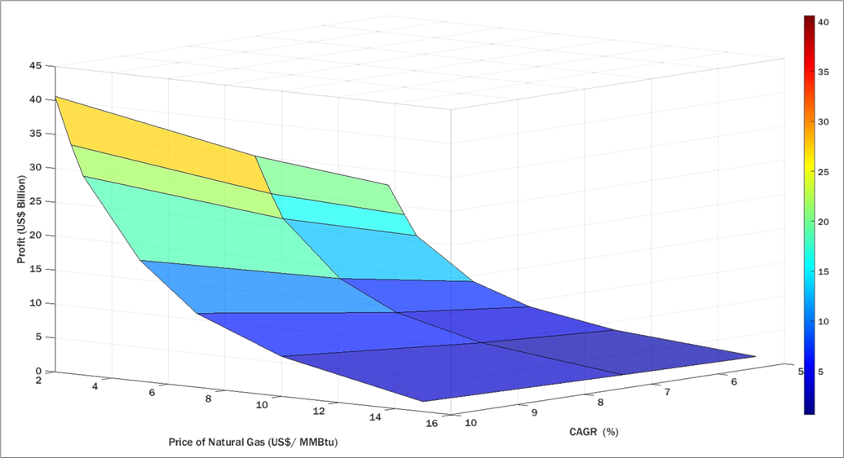
Figure 2: 3D surface plot showing profitability trend with varying CAGR and Natural Gas price. Areas of higher profit are concentrated in the low-price-high-growth zone.
4.1. Comparison of Different CAGR Scenarios
The model identifies ammonia, ethylene, and propylene as the most profitable products across different scenarios. These results highlight the importance of focusing on high-value petrochemicals to maximize returns.

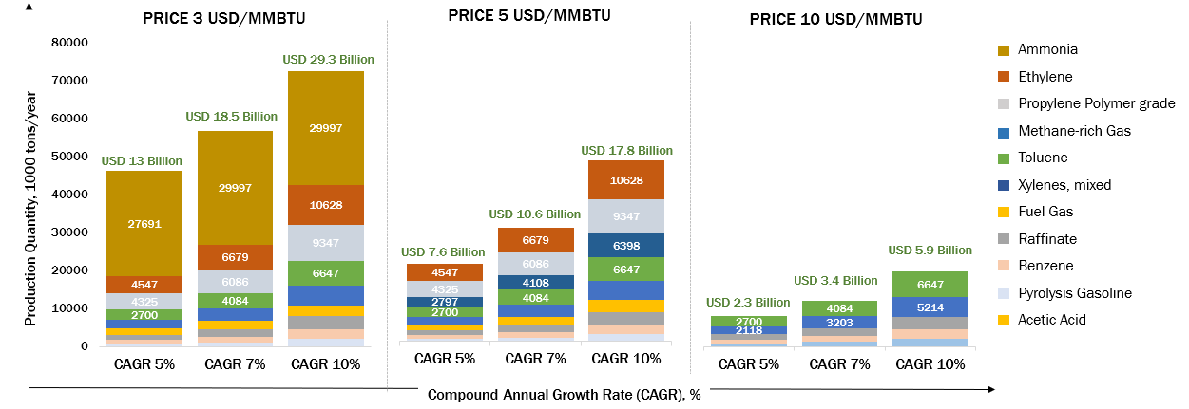
Figure 3: Linear Programming Model results of product selection trends across scenarios. High-value products like ethylene and ammonia dominate under low gas prices and high growth rates
i) High Growth Scenario (CAGR Above 7%): The modelling results indicate that at a CAGR of 7% or higher. Ethylene (6.679 million tonnes), Propylene (6.086 million tonnes), have the highest production volumes, which indicates strong demand from industrial and agricultural sectors. Fuel gas utilization and raffinate indicate limited growth, indicating that their market demand remains weak even for high-growth conditions. The increase in revenue suggests that higher growth rates enable market expansion, potentially increasing exports.
ii)Moderate Growth Scenario (CAGR Around 5%): In this scenario, total production is ~28% lower than in the high-growth scenario. Ethylene production remains strong at 4.547 million tonnes along with propylene (4.325 million tonnes) as in the high growth scenario, however, there is a noticeable decrease in fuel gas and raffinate output. This indicates that moderate growth supports high-demand petrochemicals as ethylene and propylene and does not improve the outlook for lower-demand products, such as raffinate, similar to the high growth scenario.
4.2. Energy requirements for Ethylene production
Ethylene is a fundamental building block for the petrochemical industry, with widespread applications in the production of plastics, synthetic fibres, and various chemicals. In India, where the petrochemical sector is rapidly expanding to meet domestic demand and support industrial growth, optimizing energy consumption and reducing carbon emissions at the ethylene production level is important for sustainable development and energy security. Beyond quantifying energy demand and emissions, the second aim of this study is to evaluate the financial and technical feasibility of scaling renewable energy integration in India’s ethylene production industry. For an ethylene production capacity of 10.628 million tons, the total energy requirement is estimated to be 76.78 million MWh, derived from 276.4 PJ using the conversion factor 1 PJ = 277,777.78 MWh. A phased integration over 20 years is proposed, with annual renewable energy replacement of 767.78 GWh to achieve 20% electrification.
Applying a 1% replacement rate annually leads to an incremental replacement of 7,678 MWh per year (7.68 GWh per year). This approach allows for the gradual integration of renewable energy sources into ethylene production, along with reducing operational disruptions. The detailed results are shown in Table 2.
The ONSET tool played an important role in providing real-world energy data for this model, ensuring that calculations are aligned with actual energy infrastructure and renewable potential. Key data inputs from the ONSET tool played an important role in estimating emissions and assessing renewable integration A grid emission factor of 0.65 kg CO₂ per kWh was determined by ONSET, which enabled precise estimation of emissions associated with electricity use during the shift from conventional to renewable sources. ONSET also provided efficiency values for major renewable technologies 65% for green hydrogen, 80% for biomass, and 90% for solar with battery storage, allowing for a realistic assessment of energy performance across different transition scenarios. In terms of energy use, the model assumed an energy intensity of 27 GJ per ton of ethylene produced Worrell et al. (2000), which was used to estimate the total energy requirement for a projected ethylene output. Based on this, total emissions from fossil-based electricity were calculated by multiplying the total electricity required (in kWh) by the emission factor (0.65 kg CO₂/kWh), resulting in an estimate of CO₂ emissions under conventional energy use.
The Levelized Cost of Electricity (LCOE) for different renewable sources is obtained from ONSET, with green hydrogen at $45 per MWh, biomass at $50 per MWh, and solar + battery at $58 per MWh. Based on this data, an assessment was performed for a 10.628-million-ton ethylene production capacity, obtaining fossil fuel emissions of 73,883,187kg CO₂.
Table 2: Total energy consumption for Ethylene Production in India
Parameter | Value
Ethylene Production Capacity | 10.63 million tons
Total Energy Requirement | 76.78 million MWh
Energy Replacement (20% transition) | 15.36 million MWh
Annual Replacement (1% per year) | 7,67,778 MWh
Incremental Replacement (1% per year) over 20 years | 7,678 MWh (7.68 GWh)
Total Fossil Fuel Emissions | 73.88 million kg CO₂ per MWh
Green Hydrogen Energy Needed | 130.45 million MWh
Green Hydrogen Cost (@ US$45/MWh) | $6.52 billion
Biomass Energy Needed | 106.00 million MWh
Biomass Cost (@ US$50/MWh) | $4.45 billion
Solar + Battery Energy Needed (@ US$58/MWh) | 94.22 million MWh
  - Conclusions
This study evaluates how India’s petrochemical sector can balance profitability and sustainability in the phase of evolving global energy market dynamics and challenges posed by climate change. Using Linear Programming framework combined with renewable energy utilization scenario modelling, the impact of fluctuating natural gas prices and varying compounded annual growth rates (CAGR) may impact industrywas analysed.The results show that the industry’s profit potential is highly sensitive to feedstock costs. The highest projected profitability $20.19 billion was achieved under a low natural gas price scenario of $2/MMBtu combined with a 5% CAGR. However, as gas prices rise, profitability drops significantly due to increased production costs.
The study also assessed the environmental benefits of partially electrifying ethylene production. With a total energy requirement of 76.78 million MWh for a production capacity of 10.63 million tons identified by the LP model. A phased electrification approach targeting 20% transition over 20 years will require 15.36 million MWh of renewable energy, wherein green hydrogen, biomass, and solar with battery storage were evaluated.
In summary, this research provides the first step for policymakers, investors, and industry leaders. The importance of integrating economic optimization with sustainability planning is reiterated. Strategic decisions in areas such as feedstock sourcing, market expansion, and renewable energy adoption are the essential levers to envision a competitive and climate-resilient future for India’s petrochemical industry.
Disclaimer:
In this article, the views and opinions of the authors expressed herein do not necessarily state or reflect those of the Government of India or any agency thereof. The financial estimates used for analysis may be classified as Class 5 at the Concept Screening Level. These estimates are essentially employed for planning of research and development activities to identify the highest impact areas.
References:
Al-Amer, A.M.J., Al-Fares, H., and Rahman, F. (1998). Towards modelling the development of the petrochemical industry in the Kingdom of Saudi Arabia, The Arabian Journal for Science and Engineering, Volume 23, Number 1B,113-126.
Derosa, S.E., Kimura, Y., Stadtherr, M.A., McGaughey, G., McDonald-Buller, E., and Allen, D.T. (2019). Network modelling of the U.S. petrochemical industry under raw material and Hurricane Harvey disruptions. Industrial and Engineering Chemistry Research, 58(28), 12801–12815. \
Fathi-Afshar, S., and Yang, J. (1985). A study of the development of a Mexican petrochemical industry using mixed-integer programming. Chemical Engineering Communications, 33(1–2), 1–22.
Fathi-Afshar, S. et al., (1981). Advances in petrochemical technology assessment. Chemical Engineering Science, 36(9), 1487–1511.
Federation of Indian Chambers of Commerce and Industry. (2022). India Chem 2022 post show report. FICCI.
India Brand Equity Foundation (IBEF) Chemical Industry in India. A comprehensive overview of the Indian chemical sector’s market drivers and investment opportunities.
Indian Chemical Council. (2024). Chemical and Petrochemical Statistics at a Glance – 2024. Indian Chemical Council, Mumbai, India.
International Energy Agency (IEA). (2022). The Future of Petrochemicals: Towards More Sustainable Plastics and Fertilizers. IEA, Paris, France.
Kapur, D. (1994), On industrial performance: Technology, policies and institutions in the Indian petrochemical industry. Ph.D. dissertation, Princeton University, UMI Dissertation Services, Ann Arbor, MI, USA.
Manne, A.S., and Markowitz, H.M. (Eds.). (1961). Studies in Process Analysis: Economy-wide Production Capabilities. John Wiley & Sons, New York, NY, USA.
Petroleum Planning & Analysis Cell (PPAC). (2023). Snapshot of India's Oil & Gas Data: Monthly Ready Reckoner – July 2023. Ministry of Petroleum & Natural Gas, Government of India, New Delhi, India.
Ren, T. et al., (2004). Olefins from conventional and heavy feedstocks: Energy use in steam cracking and alternative processes. Energy, 29(11), 1839–1854.
Skouteris, A. et al.(2021). Systems analysis of natural gas liquid resources for chemical manufacturing: Strategic utilization of ethane. Industrial and Engineering Chemistry Research, 60(33), 12377–12389.
Stadtherr, M.A., and Rudd, D.F. (1978). Resource management in the petrochemical industry. Management Science, 24(7), 720–733. The authors present early work on integrating material and economic resource planning for the petrochemical sector.
Statista. (2022). Energy consumption and chemical output metrics. Statista, Hamburg, Germany. This commercial database offers graphical data on chemical production, prices, and demand globally.
Worrell, E.,et al. . (2000). Energy Use and Energy Intensity of the U.S. Chemical Industry. Lawrence Berkeley National Laboratory, Berkeley, CA, USA.
Response to Reviewer’s Comments
REVIEWER # 1
Paper # 126
Title A PROCESS ENGINEERING ANALYSIS ON THE IMPACT OF EL ............
by:Chauhan B.,Sahir A.

Is the contribution original and up-to-date? :.............................poor
Has it engineering / scientific relevance?:................................poor
Is the presentation clear with a good expression of English?:..............poor
Are references written according to Harvard Style?:........................no
Is this paper referencing any Chemical Engineering Transactions article?:..no

decision: accept after major revisions

Comments by reviewer: Please visit also: www.aidic.it\e2dt2025\review\commenti\126vanhzvaz_f.docx
.......

The authors are very grateful to the reviewers for their thorough comments which has greatly helped in enriching the quality of the manuscript.

1. Title: The title formatting is not in line with CET specifications.
Response: The title has been updated and reformatted to align with the CET formatting specifications.
2. Authors: A space is present before the authors list. Please remove it to be compliant with CET specifications.
Response: The unnecessary space before the authors list has been removed to comply with CET formatting requirements.
3. Abstract: A strange symbol is present before the first work of the abstract. Please remove it.
Response: The symbol has been removed, and the abstract has been updated.
4. General: A space has been added by the authors between each paragraph. This is not in line with CET style. Please remove it from each part of the manuscript.
Response: All extra spaces between paragraphs throughout the manuscript have been removed to conform with CET formatting style.
5. Abstract: Please add a space between “rate” and “(10%)”.
Response: The missing space between “rate” and “(10%)” has been added.
6. General: A tab has been added between each number and each identifier of a section. Please remove it to be compliant with CET guidelines.
Response: All tabs between section numbers and section titles have been removed and replaced with correct formatting per CET guidelines.
7. Introduction: A typo is present. “Fibers” should be replaced with “fibres”.
Response: The word “Fibers” has been corrected to “fibres” in accordance with British English spelling as used in CET.
8. Introduction: A typo is present, since an extra and non-required space is added between “12.2%” and “reaching”. Please remove it.
Response: The extra space has been removed to ensure correct spacing and consistency.
9. Introduction: What does “LP” means? It is an abbreviation that does not have been explained yet in the text before it first appearance.
Response: The abbreviation “LP” has been defined as “Linear Programming” at the first appearance.
10. Introduction: A typo is present since “analyzed” should be replaced by “analysed”.
Response: The term “analyzed” has been changed to “analysed” to follow British English usage.
11. Introduction: It has been stated that “my research aims to …” whereas in impersonal for is recommended. Please use “this research aims to…”.
Response: The phrase “my research aims to…” has been revised to “this research aims to…”. and the impersonal form has been used throughout the manuscript.
12. Section 2: The header of the section does not use full bold characters. Please fix it.
Response: The Section 2 header has been reformatted as advised.
13. Section 2; References have been reported in square brackets, whereas CET style requires different formatting, more in line with the citation setting previously used in the manuscript. Please be compliant with CET guidelines.
Response: All references in Section 2 (and throughout the manuscript) have been reformatted to align with CET citation guidelines, removing square brackets.
14. Section 2: You have made reference to “Manne” work and then you said that “they have…”. Please use “Manne et al.” to refer to a group of authors (number greater than 2). Please check the indications of how to refer to authors in the CET template, in which the guidelines are reported. This consideration must be applied all over the paper.
Response: The reference to “Manne” has been updated to “Manne et al.” when referring to multiple authors. Similar corrections have been made throughout the manuscript following CET style.
15. Section 2: Before Figure 1 a period is missing.
Response: A period has been added before Figure 1 to ensure grammatical completeness.
16. Section 2: After Figure 1 a bullet point series is reported. This is not compliant to CET guidelines, if not properly introduced in the text. Please reformulate in a more written and readable form. Moreover, in the bullets points additional strange symbols are reported.
Response: The bullet points following Figure 1 have been rewritten in narrative form and properly introduced within the text. All unusual symbols have also been removed.
17. Section 2: Equations are not reported according to the CET guidelines. This consideration must be applied to all over the manuscript.
Response: All equations have been reformatted according to CET specifications, including alignment, numbering, and referencing.
18. Section 3: It is reported “[Reference]” in the manuscript. First, references must not be reported in square brackets, second the reference is missing.
Response: The placeholder “[Reference]” has been replaced with the correct reference in CET format, and all missing references have been added.
19. Section 3: Table 1, Figure 1 and Figure 2 are reported without any introduction in the manuscript. Every figure and table must be presented in the manuscript before their first appear.
Response: Each table and figure is introduced in the main text.
20. Section 3: Between Figure 1 and Figure 2 typos are present, like to space after “CAGR” and “favorable” must be replaced with “favourable”.
Response: The double space after “CAGR” has been corrected, and “favorable” has been changed to “favourable” to adhere to British English spelling.
21. Section 4: References are still missing or reported in a wrong way, like “Ren at al., 2004]” and “[]”.
21. Section 4: References reported incorrectly (e.g., “Ren at al., 2004]” and “[]”).
Response: All references in Section 4 have been reviewed and reformatted. Errors such as “Ren at al.” have been corrected to “Ren et al.,” and stray brackets have been removed.
22. Section 7: References are reported in bullet points and not with CET format.
Response: The references in Section 7 have been reformatted into a continuous text structure according to CET guidelines, and bullet points have been removed.
23. General: The methodology used in the manuscript is not clear at all and have not been presented anywhere. The novelty of the work does not arise clearly, and the paper is not very well written. Also, results are not presented in a clear way.
Response: The authors appreciate the concern raised by the reviewer, which has led to redrafting of the manuscript sections with greater clarity The methodology section has been expanded and clearly described, outlining the modelling framework, assumptions, and steps involved. Additionally, the results section has been revised to present findings in a more structured and clearer manner, with improved narrative flow and visual clarity in supporting tables and figures.
We are grateful for the reviewer’s suggestion.

REVIEWER # 2
Paper # 126
Title A PROCESS ENGINEERING ANALYSIS ON THE IMPACT OF EL ............
by:Chauhan B.,Sahir A.

Is the contribution original and up-to-date? :.............................sufficient
Has it engineering / scientific relevance?:................................sufficient
Is the presentation clear with a good expression of English?:..............poor
Are references written according to Harvard Style?:........................no
Is this paper referencing any Chemical Engineering Transactions article?:..no

decision: accept after major revisions

Comments by reviewer
.......
The authors are very grateful to the reviewers for their thorough comments which has greatly helped in enriching the quality of the manuscript, and for the opportunity provided to showcase their research contribution.

It is recommended that the authors work on the following

1) Assumptions in the linear programming context used

Response: We have revised the manuscript to include a section elaborating on all key assumptions made in the development of the linear programming model. These include assumptions related to process capacities, economic parameters, feedstock availability, and technological constraints. Each assumption is now justified based on previous literature studies.

2) Discussion of the theoretical framework linking linear programming with the analytics of process operations
Response: We have now included discussion in the methodology section explaining how the linear programming model integrates with process operations analytics.

3) Details on the data sources by providing transparent set of information on how the data have been collected and validated.
Response: We have expanded the data sources and validation section in methodology to include sources of all datasets used in the study. This includes primary industry data, literature-derived coefficients, and publicly available datasets. Where applicable, data validation sources, such as cross-referencing with government or peer-reviewed sources, have been mentioned. The authors feel constrained by the six page limit and look forward to provide additional data if CET allows,

4) Rechecking the citation format and the the details of the bibliography where a number of references have missing dates and relevant details.
Response: The reference list has been revised and reformatted to follow the CET referencing style. We have corrected missing dates, and author names. A final cross-check was also performed to ensure all in-text citations are properly reflected in the reference list.

